Day 25 CSV data and Pandas library

udemy.com/course/100-days-of-code/learn/lecture/20628466#overview

Pandas data analysis library – US quiz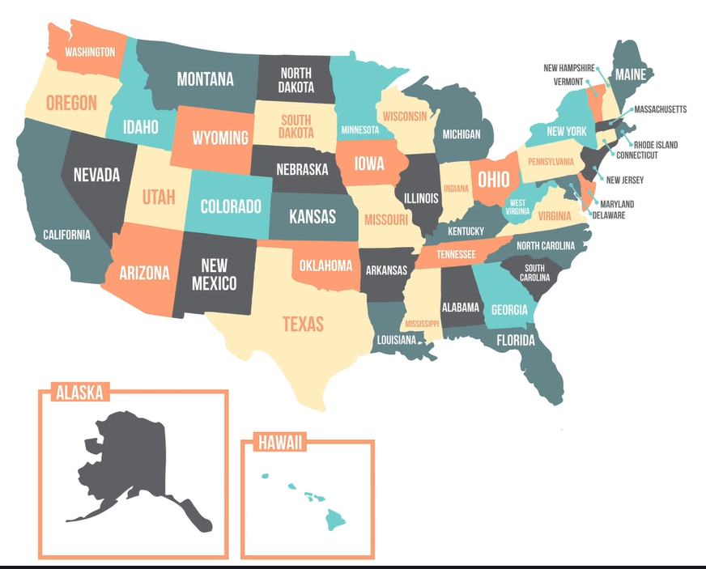

<https://pandas.pydata.org/docs/reference/index.html>

<https://pandas.pydata.org/docs/>

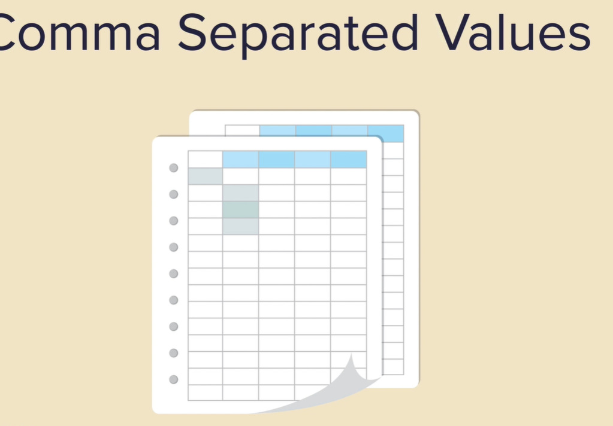

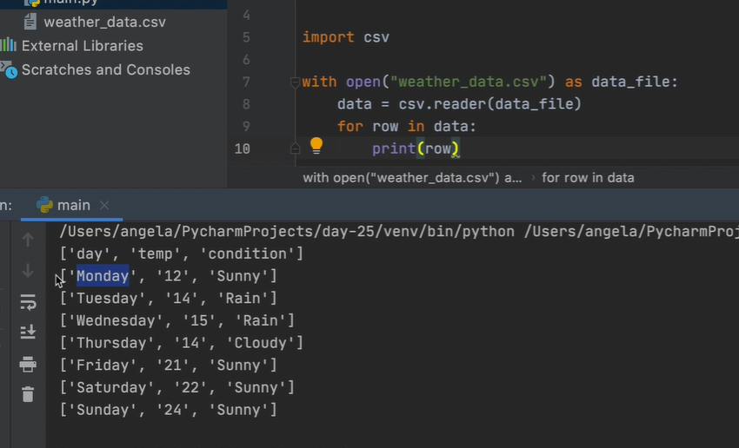

Pythons CSV library

Too much faff

# use pythons csv library https://docs.python.org/3/library/csv.html  
import csv  
with open("weather_data.csv") as data_file:  
 data = csv.reader(data_file)  
 temperatures = []  
 #data is now an object  
 for row in data:  
 # print(row)  
 # print(row[1])  
 # dont print the temp row  
 if row[**1**] != "temp":  
 # temperatures.append(row[1])  
 # convert to int  
 temperatures.append(int(row[**1**]))  
 print(temperatures)



import pandas  
  
data = pandas.read_csv("weather_data.csv")  
# print(data)  
  
# just the temperature  
  
print(data["temp"])

pandas can return data type DataFrames

a pandas DataFrames is like the equivalent of a excel spreadsheet in the pandas world

a Series is like a column in the table or a list



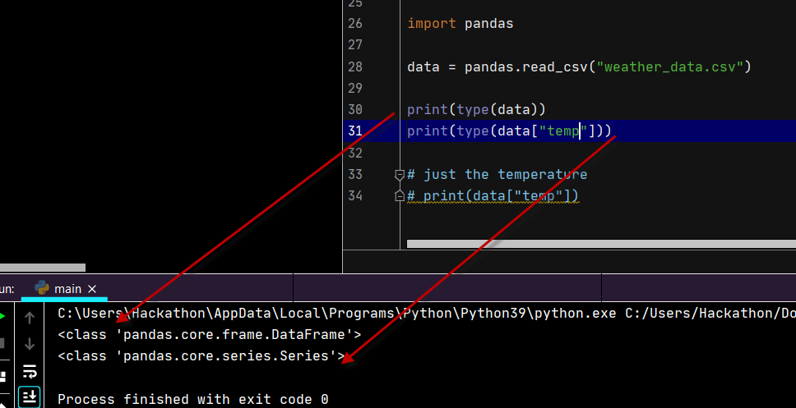

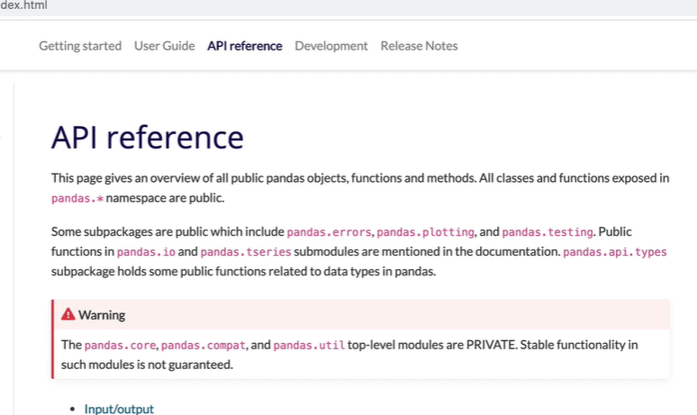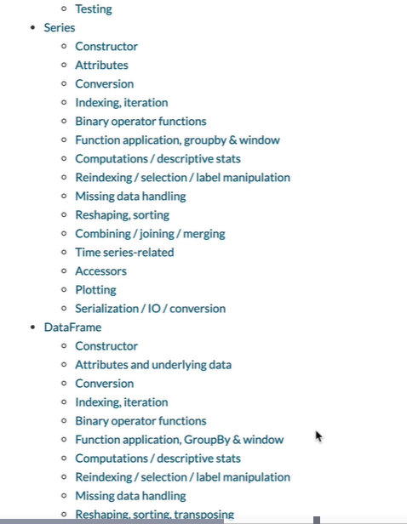

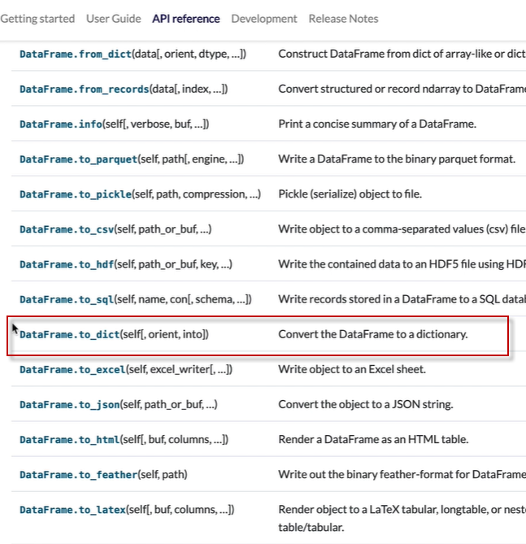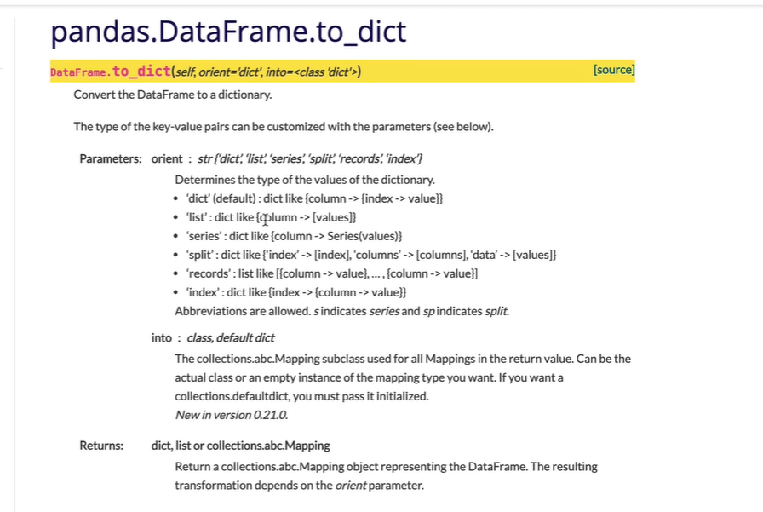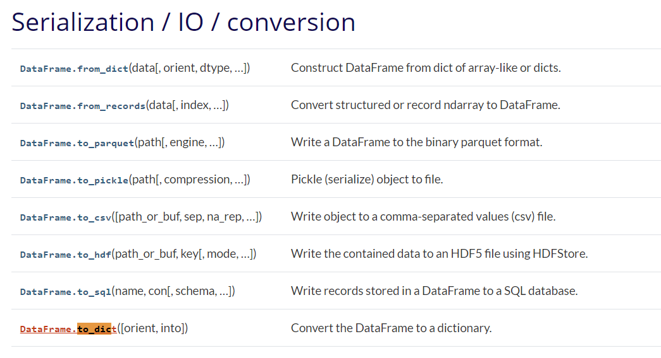

<https://pandas.pydata.org/docs/reference/api/pandas.DataFrame.to_dict.html#pandas.DataFrame.to_dict>

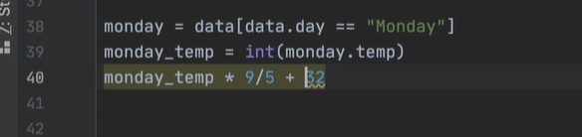

When I could not get my code to work

<https://stackoverflow.com/questions/38134643/data-frame-object-has-no-attribute>

State game – getting the cords of the states but it is in the CSV file

# Turtle  
import turtle  
  
#Panda  
  
screen = turtle.Screen()  
screen.title("US States Game ")  
image ="blank_states_img.gif"  
screen.addshape(image)  
  
turtle.shape(image)  
def get_mouse_click_coor(x**,** y):  
 print(x**,** y)  
  
turtle.onscreenclick(get_mouse_click_coor)  
  
  
  
# an alterative to keeping window open so mouse click is not closing  
turtle.mainloop()  
# screen.exitonclick()

